Manchester Metropolitan University

Name: Miles Oladipo Sasegbon

Student ID: 18054517.

Course: MSC Computing

Department: Department of Computing

Module: Information and Digital Media Systems

Tutor: Stephen Gordon/ Dr. Yanlong Zhang

Coursework Title: Individual coursework for Noahs Pet Clinic
(NPC) Multimedia

Documentation
This will require the following:
Setup and install
Download XAMPP
Install xampp
Download compressed project files
Extract project files on your system
Open NPS folder from the extracted location to xampp htdoc directory
Start xampp

System requirements
COMPONENT REQUIREMENT
Computer and processor
1.6 GHz or faster, 2-core

Memory
4 GB RAM; 2 GB RAM (32-bit)
Hard disk
4 GB of available disk space
Display
1280 x 768 screen resolution (32-bit requires hardware acceleration for 4K and higher)
Graphics
Graphics hardware acceleration requires DirectX 9 or later, with WDDM 2.0 or higher for Windows 10 (or WDDM 1.3 or higher for Windows 10 Fall Creators Update).
Operating system
Windows 10 SAC, Windows Server 2019, or Windows 10 LTSC 2019
Browser
The current version of Microsoft Edge, Internet Explorer, Chrome, or Firefox.

How to use
Open NPS with xampp (localhost)
Click continue to navigate from home page to gallery
Use menu bar to navigate between home, gallery and NPC enquiry
Storyboard
Home

kkk
Noahs Pet Clinic
NPC Logo
Welcome to
HOME | Products & Services | Gallery
Continue

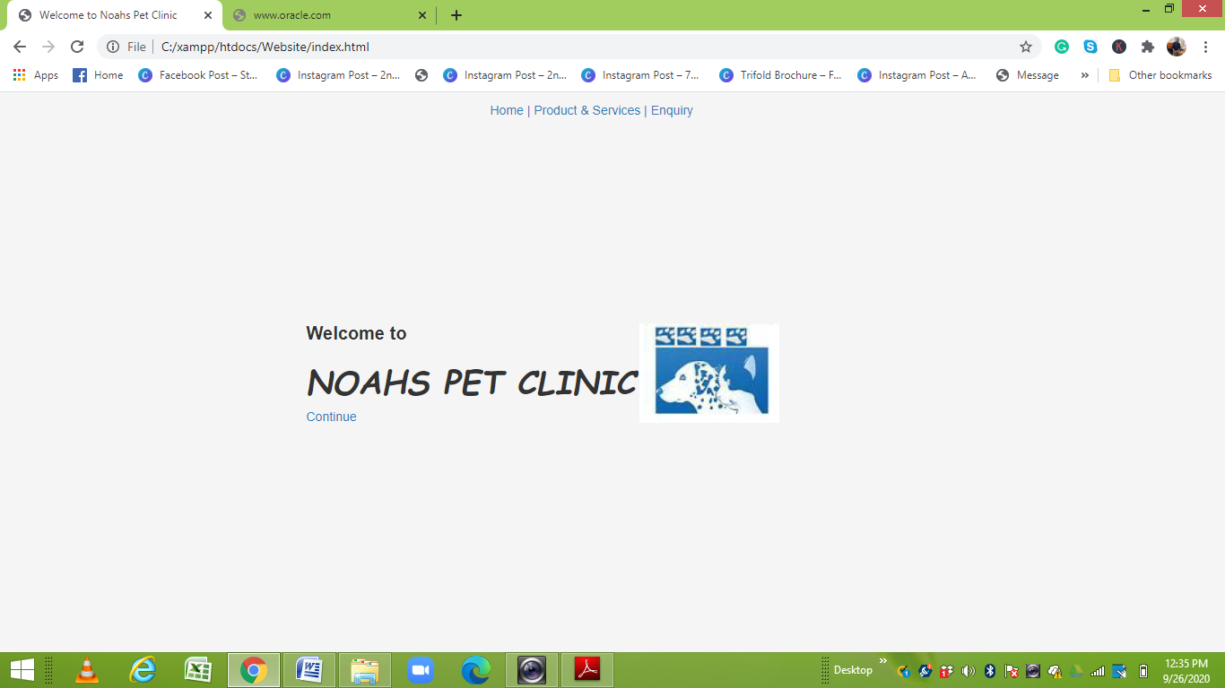
Gallery

OUR SERVICES
Image 1
Noahs Pet Clinic
HOME | Products & Services | Gallery
Image 2
Image 3
Image 4

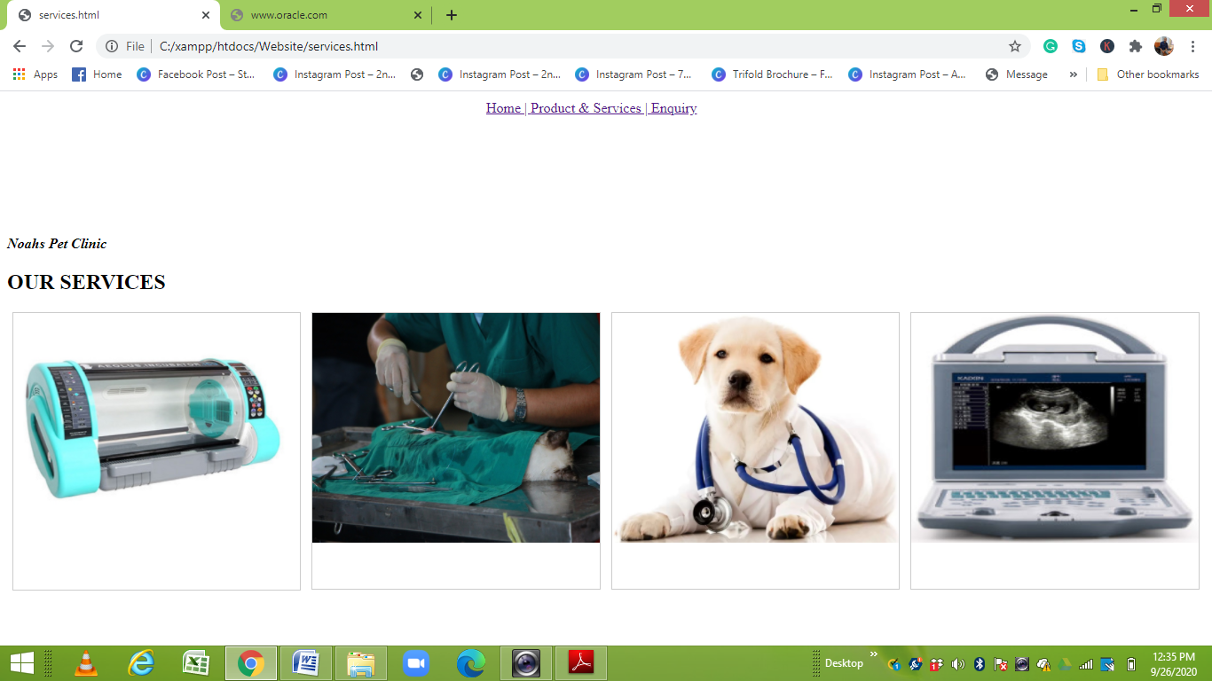

Enquiry

HOME | Products & Services | Gallery

Pet Enquiry System

Enquiry Form
Search Button

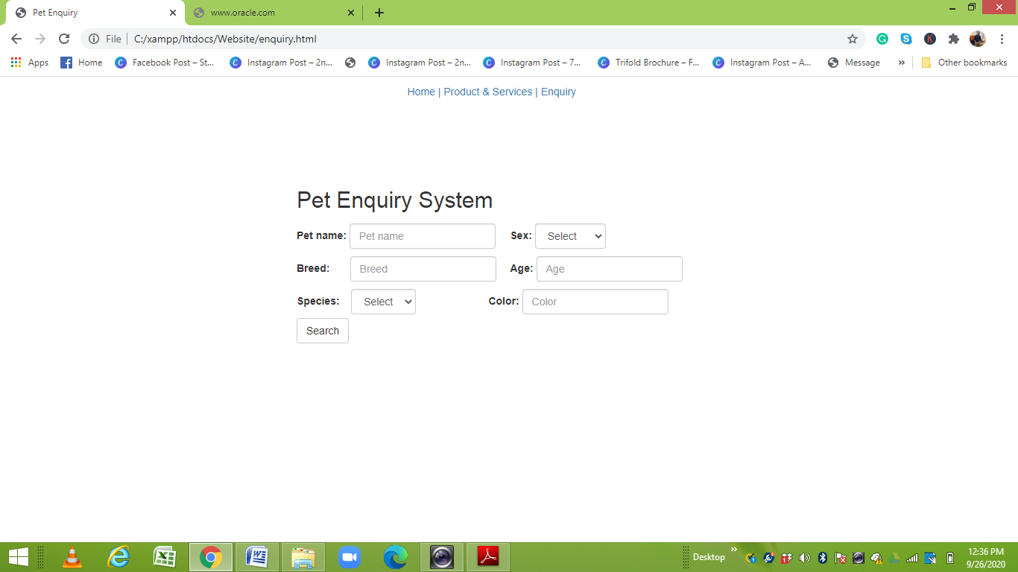

Website:
On how to run the website, the MD of NPC should do the following;

Download the NPC Folder attached; the attachment contains
1. Media prototype
2. Website files

Install: https://www.apachefriends.org/download.html
Download 7.4.11

In Extracting in the system, contain two folders
One is media
Second is website

In the media folder, the MD of NPC can play the content with windows media player or any other video player on your system

For the website, the MD of NPC will se 3 files open the index.html with Chrome or Firefox

After extracting the NCP Folder
The MD of NPC can Copy the website folder
Then, go to C:\xampp\htdocs and paste the website folder copied earlier

Database
CREATE TABLE `pets` (
`ID` int(11) NOT NULL AUTO_INCREMENT,
`ownersID` int(11) NOT NULL,
`petName` varchar(20) DEFAULT NULL,
`petAge` int(11) DEFAULT NULL,
`petGender` varchar(2) DEFAULT NULL,
`petColor` varchar(10) DEFAULT NULL,
`petWeight` varchar(10) DEFAULT NULL,
PRIMARY KEY (`ID`,`ownersID`),
KEY `ownersID_idx` (`ownersID`),
CONSTRAINT `ownersID` FOREIGN KEY (`ownersID`) REFERENCES `pet_owners` (`ID`) ON DELETE NO ACTION ON UPDATE NO ACTION,
CONSTRAINT `petID` FOREIGN KEY (`ID`) REFERENCES `pets` (`ownersID`) ON DELETE NO ACTION ON UPDATE NO ACTION
) ENGINE=InnoDB DEFAULT CHARSET=latin1;

